Final Project Report

Online portal for tracking Seeds Record for Cultivation


Project Supervisor

Mir Salam Khan

Submitted By

BC230422757

Software Projects & Research Section,
Department of Computer Sciences,
Virtual University of Pakistan


CERTIFICATE

This is to certify that student name (BC230422757) have worked on and completed their Software Project at Software & Research Projects Section, Department of Computer Sciences, Virtual University of Pakistan in partial fulfillment of the requirement for the degree of BS in Computer Sciences under my guidance and supervision.

In our opinion, it is satisfactory and up to the mark and therefore fulfills the requirements of BS in Computer Sciences.

Supervisor / Internal Examiner

Mir Salam Khan
Supervisor,
Software Projects & Research Section,
Department of Computer Sciences
Virtual University of Pakistan

___________________
(Signature)

External Examiner/Subject Specialist
<<External Supervisor Name>>

___________________
(Signature)

Accepted By:

_____________
(For office use)

EXORDIUM

In the name of Allah, the Compassionate, the Merciful.

Praise be to Allah, Lord of Creation,
The Compassionate, the Merciful,
King of Judgment-day!

You alone we worship, and to You alone we pray for help,
Guide us to the straight path

The path of those who You have favored,

Not of those who have incurred Your wrath,
Nor of those who have gone astray.

DEDICATION



IN THE NAME OF ALLAH THE MOST BENIFICIENT THE MERCIFUL

I dedicate this Project to my beloved
Father & Teachers
And
To the Loving memory of my Mother
And also
To my brothers & sisters.
You have successfully made me the person I am becoming
You will always be remembered.

ACKNOWLEDGEMENT

Foremost, I am highly grateful to Allah for His blessing that continue to flow into my life, and because of You, I made this through against all odds.

With a great pleasure I would like to acknowledge the support, assistances and contribution made by individuals from the beginning of the Project, providing me access, data and information, to the writing process until the completion of this project.

First of all, I want to give thanks to our project supervisors Asif Hussain for the access and assistance in order to make my project possible.

Second I would like to thank all the Mater program staff, thank you all for the assistance and constructive discussions we had during the entire courses

PREFACE

This project report has been prepared in fulfillment of the requirements for the BS in Computer Science.

For preparing of the project report, I have closely studied Online portal for tracking Seeds Record for Cultivation of certain compounds to get the knowledge of the data requirements that will be used successfully to protect any entrance breaches.

I have also studied the software that was required for this project coding like, PHP and databases.

This project started with to final coding I which have given me the ability to understand the concept of programming and move me forward smoothly.

I am very thankful to my supervisors who have helped me to complete this project and I really appreciate all his efforts and support.

I am also very thankful to Virtual University, Pakistan and all the staff.

TABLE OF CONTENTS

Chapter No. 1
Gathering & Analyzing Info 9

1.1 Introduction: 10
1.2 Purpose: 10
1.3 Scope of Project: 10
1.4 Definitions, Acronyms and Abbreviations 11
1.5 Project Requirements 11
1.5.1 Functional Requirements: 11
1.5.2 Non-Functional Requirements: 11
1.6 Use Cases and Usage Scenarios: 14
1.6.1 Use Case Diagram: 14
1.6.2 Usage Scenarios: 15
1.7 Development Methodology: 18
1.7.1 Chosen Methodology: 18
1.7.2 Reasons for Chosen Methodology: 18
1.7.3 Work Plan (Gantt Chart): 21
1.7.4 Project Schedule (Submission Calendar): 22

Chapter No. 2
Designing the project 23

2.1 Introduction: 24
2.2 Purpose: 24
2.3 Scope: 24
2.4 Definitions, Acronyms and Abbreviations: 24
2.5 Architectural Representation (Architecture Diagram) 24
2.6 Dynamic Model: Sequence Diagrams: 26
2.7 Object Model/Logical Model: Class Diagram: 31
2.8 Database Model (Database Diagram): 31
2.9 Graphical User Interfaces: 32

Chapter 3
Development 35

3.1 Development plan (Architecture Diagram) 36

Chapter 1

Gathering & Analyzing Info

Introduction:

The first draft of the Software Requirements Specification (SRS) document has been prepared for the project. This document highlights the system's primary goals and scope. It contains: Scope, Use Case Diagram, Usage Scenarios,

Chosen Methodology, Gantt Chart

Purpose:

The platform connects book lovers, helps build a community, and supports sustainability by encouraging the reuse of books. It is designed to be easy to use and accessible on devices like computers, tablets, and smartphones

Scope of Project:
The scope of this project covers the complete digital transformation of seed record tracking and management in agriculture. The portal enables end-users to search seed categories, view detailed seed profiles, and conduct online transactions. Seed agents (such as farmers or firms) can register, upload seed information, and manage their profiles after admin approval. The admin oversees user registrations, approves access, and maintains system integrity. A significant feature of the system is seed traceability, which allows tracking of seed origin, climate adaptability, and usage history. Additionally, integrated dashboards offer real-time analytics to support data-driven decisions. The system aims to improve transparency, efficiency, and productivity in Pakistan's agriculture sector by providing a reliable, secure, and user-friendly platform for all stakeholders.

Definitions, Acronyms and Abbreviations

• HTML (Hyper Text Markup Language)
• CSS (Cascade Styling Sheet
• DBMS (Database Management System)
• SQL (Structured Query Language)

Project Requirements

Functional Requirements:
End-User:
➢ The end-user visits the seeds web portal through domain name.
➢ The user searches the different categories of seeds.
➢ The user searches the required seeds with its full detail.
➢ The user can search the seed agent (farmer, Researcher or firm) profile
➢ The user can place the order to buy/sell the seeds
➢ The user can manage transaction and payment processing
Seed Agent:
➢ The seed agent will register to the portal first by providing the requisite information on form
➢ After Admin approval, the agent can login and upload the seed detail to the portal after
authentication
➢ Provide relevant contact information
➢ Provide online payment methods
Admin:
➢ The Admin will login to the system
➢ The Admin will grant approval to the registered farmers, Researchers, Agriculture centers
➢ The Admin will provide user name and password to the farmers, Researchers and Agriculture Centers or firms.
➢ The Admin will provide analytical dashboard for making better decisions

2.2 Non-Functional Requirements:

Non-functional requirements are the criteria that define how a system should behave, rather than what it is supposed to do. Unlike functional requirements, which describe specific system functions, non-functional requirements define aspects like performance, security, usability, reliability, and scalability.

- Usability
The system must provide a user-friendly and intuitive interface for students, faculty, and admin users. It should be easy to navigate with minimal training.
- Performance
The system should respond quickly to user actions, ensuring smooth operations even under heavy usage, especially during submission and evaluation periods.
- Scalability
The system should be scalable to accommodate a growing number of users, research papers, and roles without performance degradation.
- Reliability
The system must ensure high availability and consistent functionality to avoid disruptions during critical academic activities like paper submission or evaluation.
- Security
Strong authentication, role-based access control, and secure file uploads should be implemented to protect sensitive data and prevent unauthorized access.
- Maintainability
The codebase and database structure should be modular and well-documented to allow easy updates, debugging, and future enhancements.
- Compatibility
The system must be compatible across various browsers (Chrome, Firefox, Safari, etc.) and devices (desktop, tablet, mobile).
- Accessibility
The system should comply with accessibility standards (e.g., WCAG) to support users with disabilities, including screen reader compatibility and keyboard navigation.
- Data Privacy
Personal and academic data must be handled in compliance with privacy laws and regulations. Data should be stored securely and only accessible to authorized users

Use Cases and Usage Scenarios:

Use Case Diagram:
A Use Case Diagram visually represents the interactions between users (actors) and a system, highlighting the system's functionalities (use cases) within its defined boundaries. It shows how actors interact with specific use cases through associations and may include relationships like "include" for mandatory actions and "extend" for optional behaviors. This diagram is used to capture system requirements, communicate functionality to stakeholders, and guide the system's design by focusing on what the system should do, not how it does it.

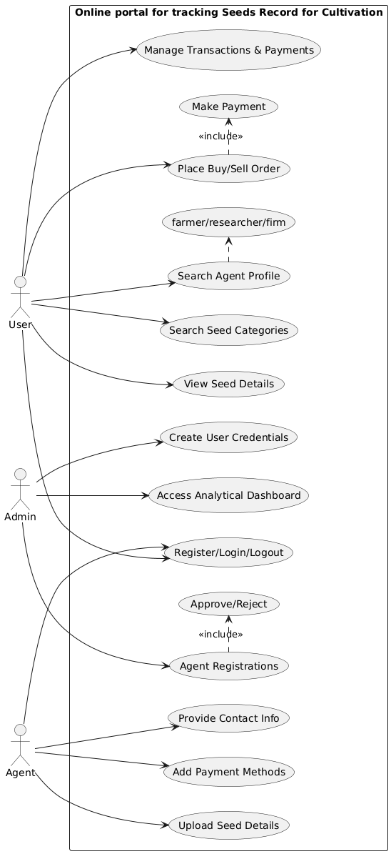

Usage Scenarios:
Usage scenarios outline how a product, service, or technology is applied to meet specific needs or solve problems in real-world contexts. They highlight key users, their goals, and the solution’s impact.

Attribute | Browse Seed Categories
Use Case ID | UC01
Actions | User visits portal and browses seed categories.
Description | Allows users to explore different categories of seeds.
Alternative Paths | No categories found → Show "No results".
Pre-Conditions | User accesses website.
Post-Conditions | Categories displayed.
Author | BC230422757
Exceptions | Network failure, no seed data.
Attribute | Search Seed Details
Use Case ID | UC02
Actions | User searches by seed name/type and views details.
Description | Enables user to find and view full details of a specific seed.
Alternative Paths | No match found → Display "No seeds found".
Pre-Conditions | Valid search input.
Post-Conditions | Matching seed details are shown.
Author | BC230422757
Exceptions | DB error, empty search results.
Attribute | View Seed Agent Profile
Use Case ID | UC03
Actions | User views profile of farmer/researcher/firm.
Description | Allows viewing of contact, seed types, and agent details.
Alternative Paths | Profile not available → Show error.
Pre-Conditions | Agent must be approved and profile uploaded.
Post-Conditions | Profile is displayed.
Author | BC230422757
Exceptions | Invalid agent ID, missing profile.
Attribute | Place Seed Order
Use Case ID | UC04
Actions | User selects seed, enters quantity, places order.
Description | Enables users to buy or sell seeds from/to agents.
Alternative Paths | Order failed → Show error.Login required.
Pre-Conditions | User is logged in.
Post-Conditions | Order submitted to the agent.
Author | BC230422757
Exceptions | Payment or server failure.
Attribute | Manage Payments
Use Case ID | UC05
Actions | User initiates or views payment status.
Description | Allows tracking of transaction and payment progress.
Alternative Paths | Payment declined → Prompt retry.
Pre-Conditions | Order must be placed.
Post-Conditions | Transaction recorded and payment status updated.
Author | BC230422757
Exceptions | Payment gateway error.
Seed Agent

Attribute | Register Seed Agent
Use Case ID | UC06
Actions | Agent fills form and submits registration.
Description | Enables seed agent to register on the portal.
Alternative Paths | Duplicate entry → Prompt correction.
Pre-Conditions | Internet access.
Post-Conditions | Registration sent for admin approval.
Author | BC230422757
Exceptions | Validation or DB error.
Attribute | Login Seed Agent
Use Case ID | UC07
Actions | Approved agent enters credentials and logs in.
Description | Authenticates approved seed agent.
Alternative Paths | Invalid credentials → Show error.
Pre-Conditions | Agent must be approved by admin.
Post-Conditions | Session is active.
Author | BC230422757
Exceptions | Server/login failure.
Attribute | Upload Seed Info
Use Case ID | UC08
Actions | Agent uploads seed data with images and details.
Description | Enables agent to upload and manage their seed listings.
Alternative Paths | Invalid data → Prompt correction.
Pre-Conditions | Agent is logged in.
Post-Conditions | Seed listing appears to end-users.
Author | BC230422757
Exceptions | Upload failure, image error.
Attribute | Agent Contact/Payment Setup
Use Case ID | UC09
Actions | Agent enters phone, email, payment method.
Description | Enables end-users to reach agent and perform payments.
Alternative Paths | Missing fields → Show alert.
Pre-Conditions | Agent is logged in.
Post-Conditions | Contact/payment info saved.
Author | BC230422757
Exceptions | Validation error.
Admin
Attribute | Admin Login
Use Case ID | UC10
Actions | Admin enters credentials and logs in.
Description | Authenticates admin to access backend panel.
Alternative Paths | Invalid credentials → Show error.
Pre-Conditions | Admin account exists.
Post-Conditions | Admin dashboard loaded.
Author | BC230422757
Exceptions | Session error, incorrect credentials.
Attribute | Approve Agent Registration
Use Case ID | UC11
Actions | Admin reviews and approves/rejects agent request.
Description | Only approved agents can access the portal.
Alternative Paths | Reject → Notify applicant.
Pre-Conditions | Agent submitted registration.
Post-Conditions | Login credentials are generated.
Author | BC230422757
Exceptions | Server/database failure.
Attribute | Create Credentials
Use Case ID | UC12
Actions | Admin sets username and password for agent.
Description | Allows secure login for registered seed agents.
Alternative Paths | Duplicate username → Prompt for change.
Pre-Conditions | Agent is approved.
Post-Conditions | Credentials sent to the agent.
Author | BC230422757
Exceptions | Credential setup failure.
Attribute | Analytics Dashboard
Use Case ID | UC13
Actions | Admin accesses reports, charts, and stats.
Description | Helps admin make informed decisions based on activity logs.
Alternative Paths | Filter by date/type.
Pre-Conditions | Admin logged in.
Post-Conditions | Insights displayed.
Author | BC230422757
Exceptions | Data load failure.

Adopted Methodology:

Let’s see what the word methodology really means.
The branch of philosophy that analyze the principles and procedures of inquiry in a particular discipline and here in software development, methodology is a predefined standard procedure to accomplish a development goal successfully. Software engineering discipline provides a number of methodologies for project management.

Existing Methodologies:

We have studied a number of methodologies in our Software Engineering-II course such as Build & Fix Model, Waterfall Model, Rapid Prototyping Model, Integrated Waterfall and Rapid Prototyping Model, Rapid Application Development Model, Synchronize & Stabilize Model and Spiral Model. Of course, there are many other models available in the market like Feature Driven Development, Extreme Programming (XP) Model, and Dynamic System Development Model and SCRUM etc.
Study shows that each methodology has its unique benefits and drawbacks.
Let’s have a close look on the prominent methodologies of the day.
Waterfall Model:

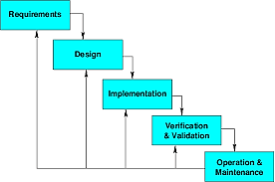
Model Description:

Owing to its cascaded design it is called waterfall model; it is also known as linear sequential model. A conventional waterfall model comprises of five stages: first one is Requirement Definition stage, second is System and Software Design, third is Implementation and Unit Testing, forth is Integration and System Testing and the last one is Operation and Maintenance. Practically, the proposed design flow of the waterfall model is rarely followed. In real projects errors and mistakes of any stage should be traced and report back to the source for necessary amendment and relevant documents should also be updated accordingly. This model is document driven so, it provides sufficient documentation and no stage is considered complete until the documentation of relevant stage is complete. In real life waterfall model-based projects, there exists a feedback loop from any stage to its previous stage. The down side of this model is its late feedback from the end user / customer which comes at the end of project and thus led to time and cost related problems in case of any incompliance, it may cause a threat for concern project.

Spiral Model
Block Diagram for Spiral Model:

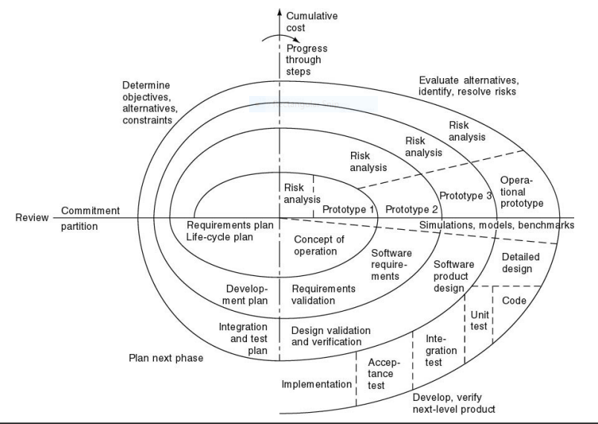

Model Description:

Spiral Model is developed by Barry Boehm and the central idea behind its design is to avert risk as there is always a risk factor in every software development project regarding time, cost and quality etc. This model continuously analyzes risk factors, involved in the project. The main strength of Spiral Model is that it is very sensitive to risk factor. In fact it is a combination of waterfall model plus risk analysis. Here each stage is preceded by identification of alternatives and concerning risk analysis and it is then followed by evaluation and planning for the next phase. If the encountered risks of any iteration cannot be resolved, the project is immediately terminated. There is no distinction between development and maintenance in this approach. It is suitable for only large scale projects. It is also applicable for internal or in house development. As we can see it has two dimensions, the cumulative cost to date, is represented by its radical dimension and progress is shown by its angular dimension.

VU Process Model:

Block Diagram For VU Process Model:
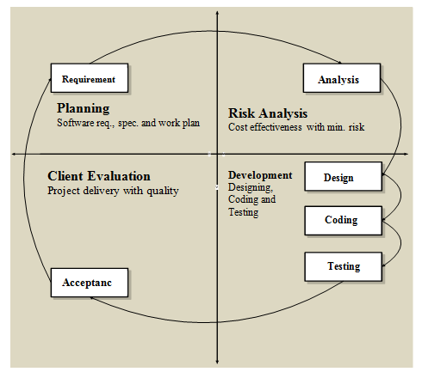

Model Description:

Virtual University of Pakistan suggests its final project students the V.U Process Model which is a combination of Spiral and Waterfall models therefore it combines the benefits of both the models i.e. Waterfall Methodology ensures and exercises strong documentation as it is a sequential and document driven methodology while Spiral Model enforce continuous risk analysis and search for alternatives. These facts make a winning combination when V.U Process Model is used in its true spirit.

Adopted Methodology

As per university guidance, adopted methodology is V.U Process Model. It has a number of salient features that direct the students to work in right direction and in the right way. It provides two strong frame works of product documentation and various risk factors analysis.

Reasons for choosing the Methodology

Combination of both Waterfall and Spiral model is called hybrid approach of system development that maximizes the quality of the system and minimizes the disadvantages and risks. VU process model has four phases which further divides the Waterfall processes. These processes are in iteration until system meets to the department’s requirement.

Work Plan (Gantt Chart):
The work plan is a document that consulting firms use to organize a project. It outlines the plan by which the company plans to complete a quality project within a given amount of time and in compliance with a set budget.
Gantt charts are useful tools for planning and scheduling projects. They allow you to assess how long a project should take, determine the resources needed and layout the order in which tasks need to be carried out. They are useful in managing the dependencies between tasks.
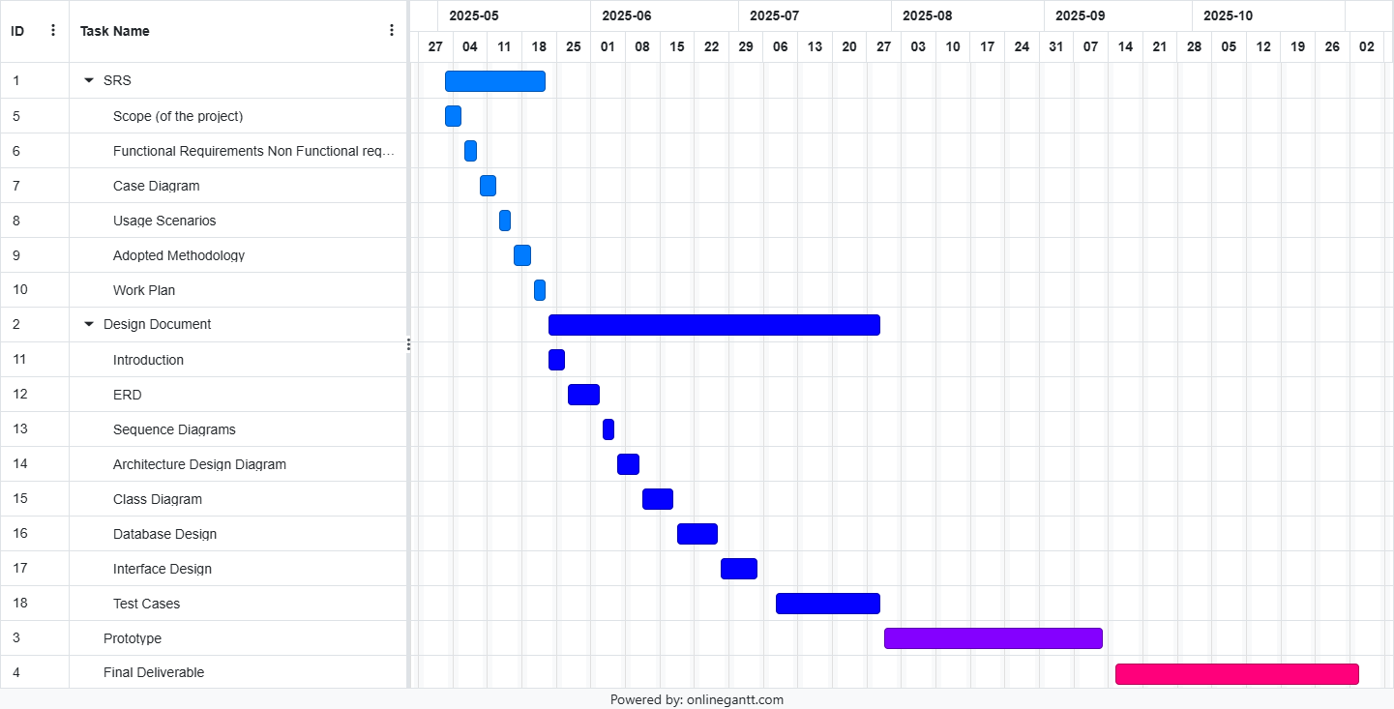

Project Schedule (Submission Calendar):

S No | Task | Start Date | End Date
01 | SRS | Fri 02 May, 2025 | Thu 22 May, 2025
02 | Design Document | Fri 23 May, 2025 | Tue 29 Jul, 2025
03 | Prototype Phase | Wed 30 Jul, 2025 | Fri 12 Sep, 2025
04 | Final Deliverable | Stat 13 Sep, 2025 | Mon 24 Nov, 2025

Chapter 2

Designing the project

Introduction:
The document provides documentation which will be used to aid in system development. The document provides the details of how the software should be built. The design document includes Entity Relationship Diagram (ERD), Sequence Diagrams, Architecture Design Diagrams, Class Diagram, Database Design, Interface design and Test Cases and other supporting requirement information.

Purpose:
The purpose of software design document is to provide a description of design of system fully enough to allow for software development to proceed with an understanding of what is to be built and how it is expected to build. The software design document provides information necessary to provide description of the details for the software and system to be built.

Scope:
The analysis and design phase in software development process is very important as it provide better management and understanding of the requirements. Additionally, system scope, verification and validation are done in analysis and design. Software quality assurance related planning is done in this phase of project.

Definitions, Acronyms and Abbreviations

• HTML (Hyper Text Markup Language)
• CSS (Cascade Styling Sheet)
• DBMS (Database Management System)
• SQL (Structured Query Language)

ERD
ERD is a diagram that shows the relationships between a group of entities stored in a database. In other words, the ER diagram helps to explain the logical structure of a database. ER diagrams consists of Entities, Attributes, and Relationships. ER diagrams have many shapes like: rectangle shape represent entities, ellipses shape define attributes, and diamond shape represent relationships

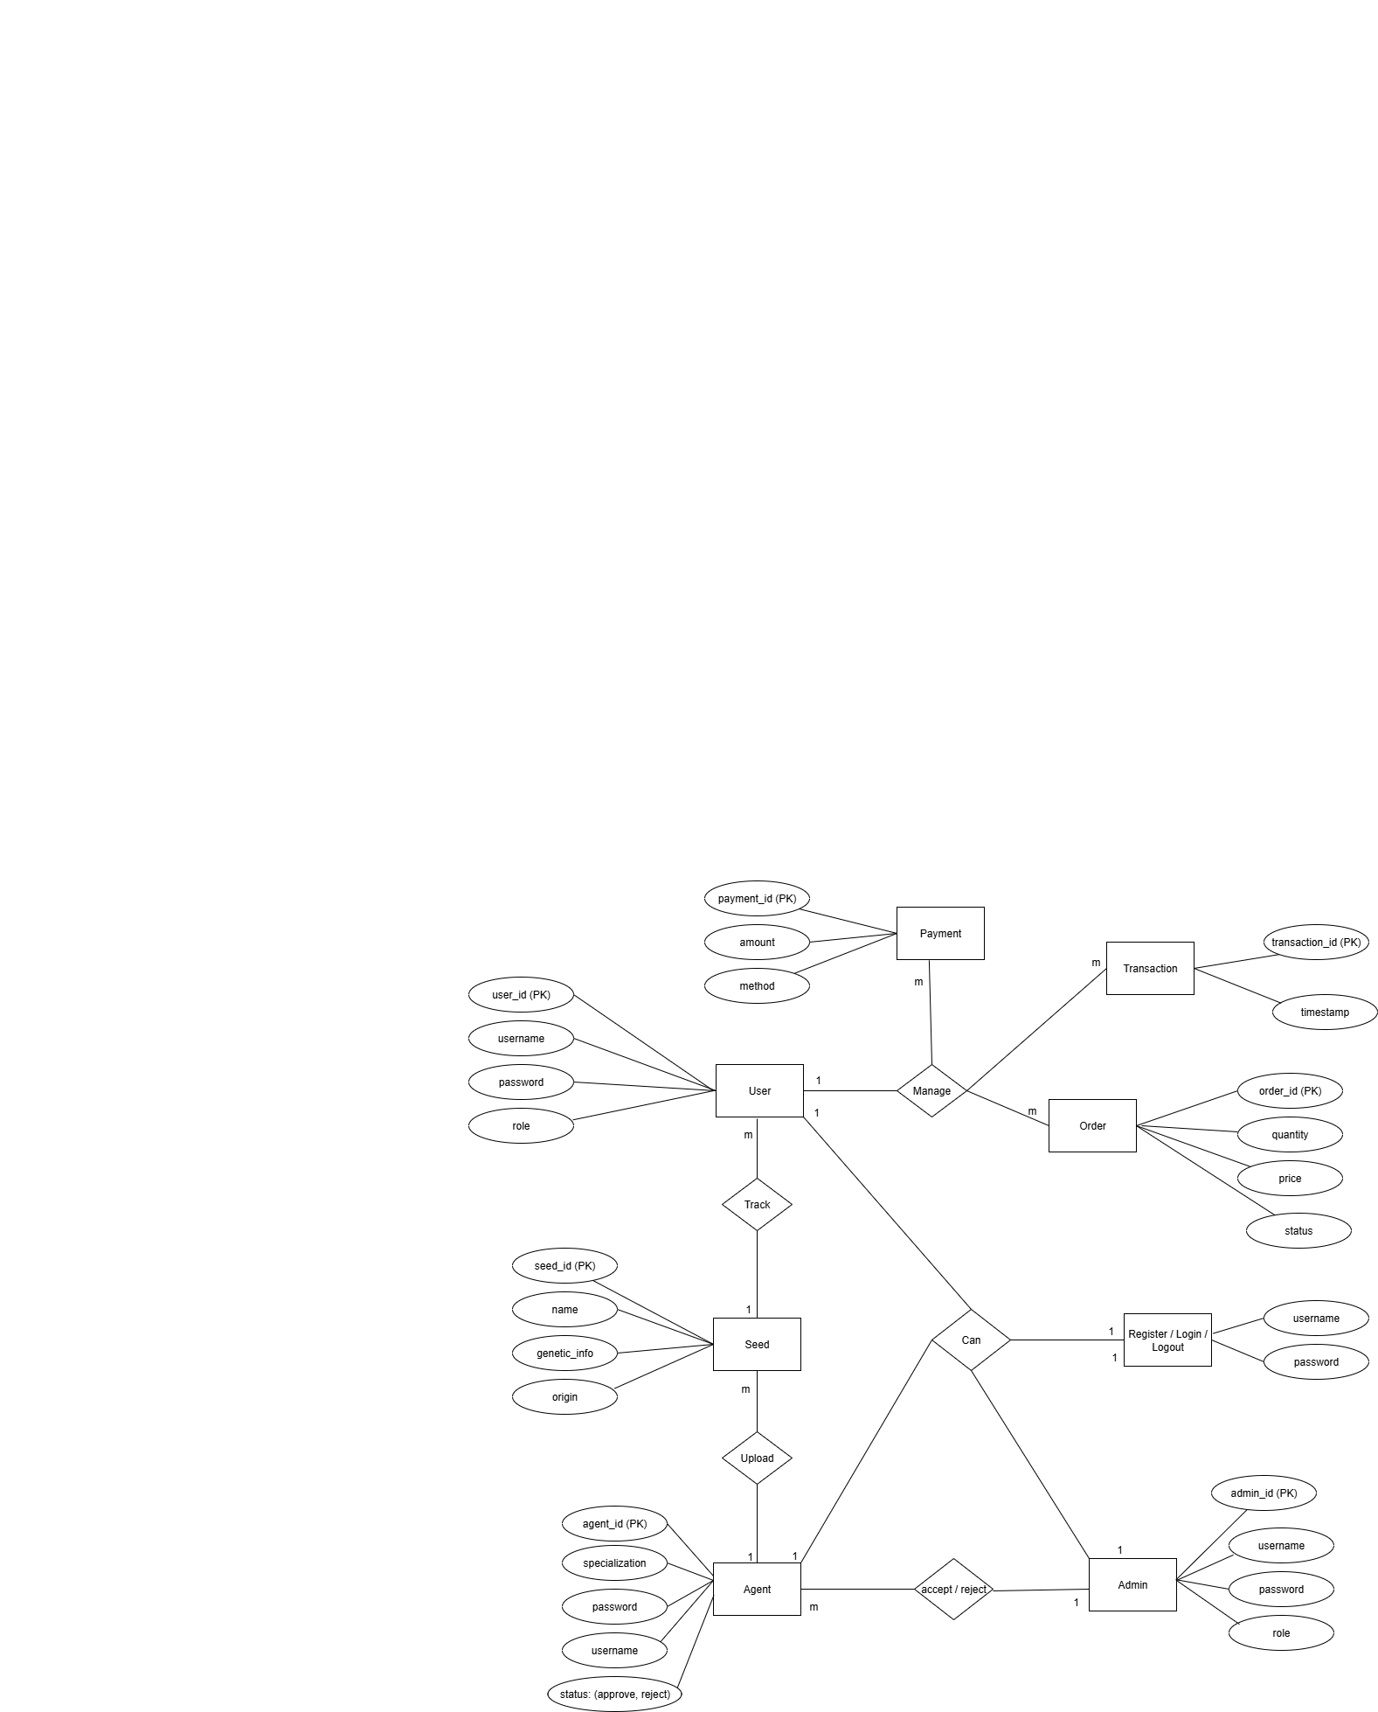

Architectural Representation (Architecture Diagram)
An architecture diagram is a visual representation of the components, relationships, and responsibilities within a software system. It shows the big picture of a software project and outlines the architecture that has been chosen.

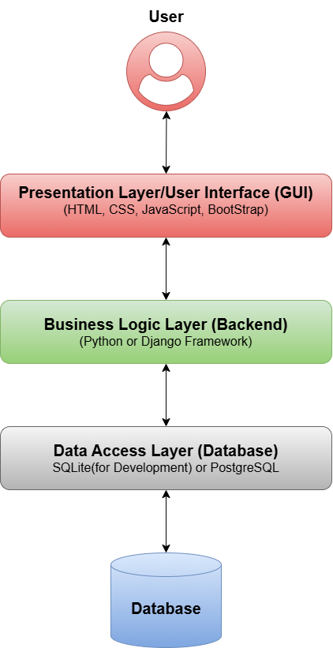

Dynamic Model: Sequence Diagrams:
Sequence diagrams are interaction diagrams that show what messages are sent and when between objects in a system. They are organized by time from top to bottom and by objects from left to right. They are used to represent all the possible interactions in a single-use case. They help to understand how a system achieves a specific goal or function.

Admin:
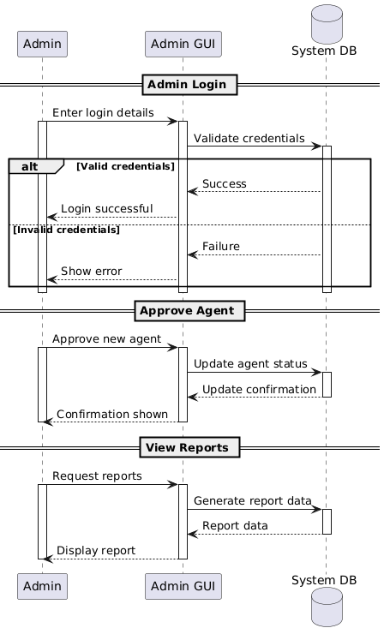
User:
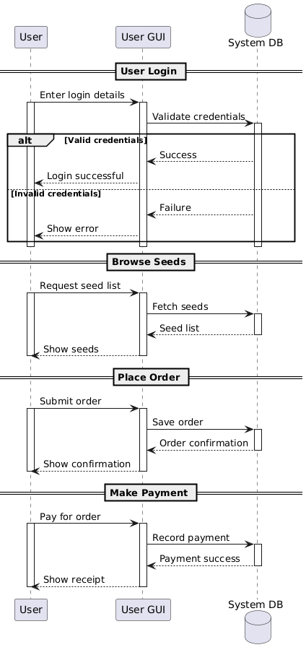
Agent:
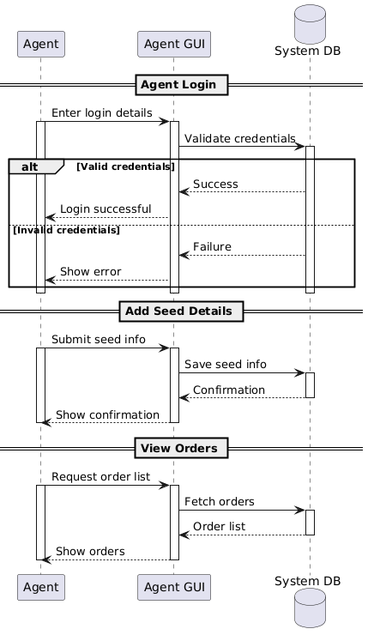

Object Model/Logical Model: Class Diagram:
A class diagram is a visual representation of the objects, attributes, and methods in a system. To create a class diagram, you need to identify the classes and their relationships, and use symbols and lines to show them.
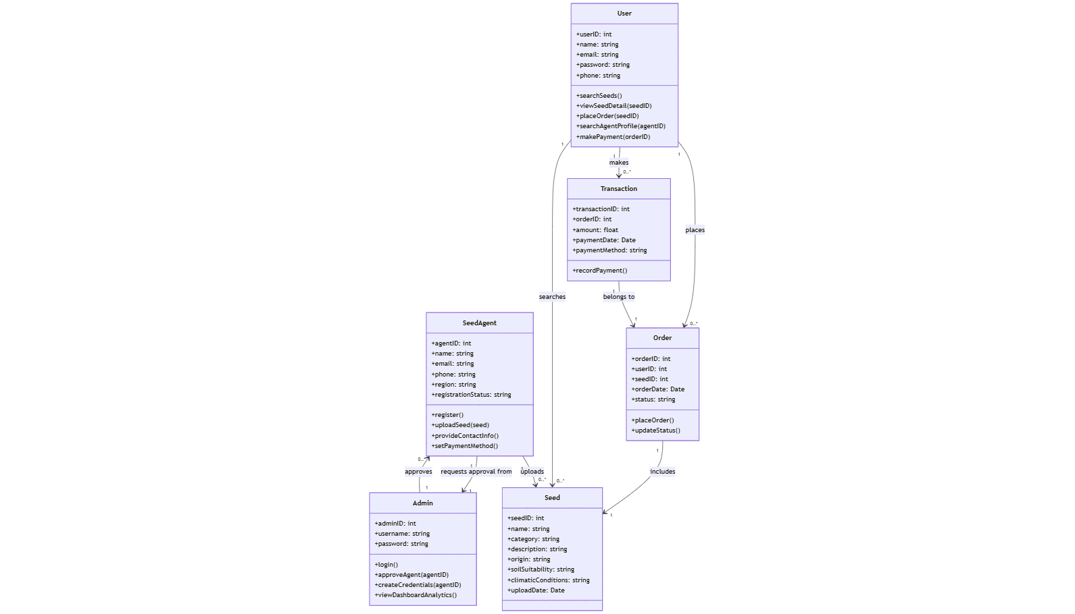

Database Model (Database Diagram):
In a database model, you define the structure of your database, including tables, columns, relationships, and constraints.
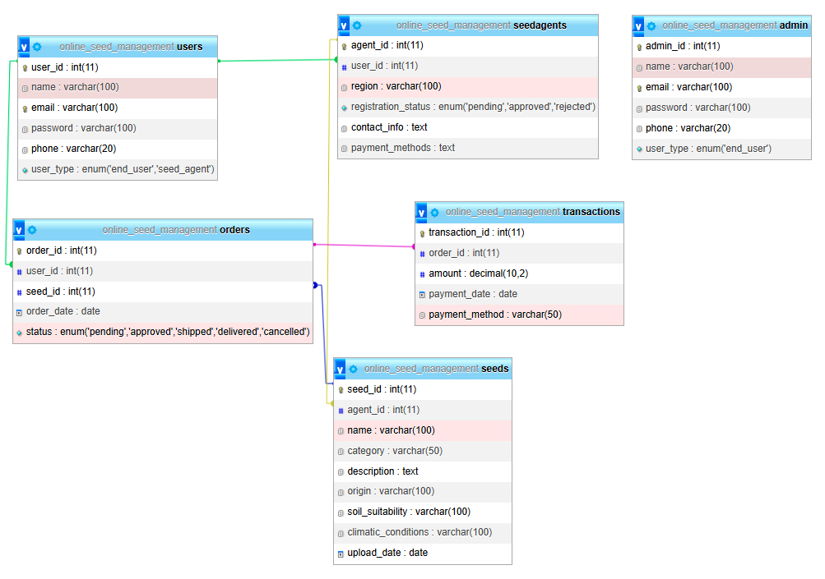

Test Case;

Field | Value
Test Case ID | TC_UC01
Attribute | Browse Seed Categories
Input | User accesses seed categories page
Output | List of seed categories displayed
Pre-Condition | User accesses website
Post-Condition | Categories displayed
Expected Result | User sees list of available seed categories or "No results"
Tested By | BC230422757
Field | Value
Test Case ID | TC_UC02
Attribute | Search Seed Details
Input | Enter valid seed name/type in search
Output | Seed details shown
Pre-Condition | Valid search input
Post-Condition | Matching seed details displayed
Expected Result | Relevant seed results shown or "No seeds found"
Tested By | BC230422757
Field | Value
Test Case ID | TC_UC03
Attribute | View Seed Agent Profile
Input | Click on agent profile
Output | Profile information displayed
Pre-Condition | Agent must be approved and profile uploaded
Post-Condition | Profile is displayed
Expected Result | Profile details appear or error if unavailable
Tested By | BC230422757
Field | Value
Test Case ID | TC_UC04
Attribute | Place Seed Order
Input | Select seed, enter quantity, submit order
Output | Order submitted to agent
Pre-Condition | User is logged in
Post-Condition | Order saved and shown in user/agent dashboard
Expected Result | Order confirmation message or error (if login/payment failed)
Tested By | BC230422757
Field | Value
Test Case ID | TC_UC05
Attribute | Manage Payments
Input | View or initiate payment
Output | Transaction recorded or status updated
Pre-Condition | Order must be placed
Post-Condition | Payment status reflected in system
Expected Result | Payment processed or retry prompt if declined
Tested By | BC230422757
Field | Value
Test Case ID | TC_UC06
Attribute | Register Seed Agent
Input | Fill and submit registration form
Output | Registration sent for approval
Pre-Condition | Internet access
Post-Condition | Request saved for admin review
Expected Result | Confirmation message or error if validation fails
Tested By | BC230422757
Field | Value
Test Case ID | TC_UC07
Attribute | Login Seed Agent
Input | Approved agent submits credentials
Output | Session activated
Pre-Condition | Agent approved by admin
Post-Condition | Agent logged into dashboard
Expected Result | Login success or error for wrong credentials
Tested By | BC230422757
Field | Value
Test Case ID | TC_UC08
Attribute | Upload Seed Info
Input | Fill seed details and upload image
Output | Seed listing visible to users
Pre-Condition | Agent is logged in
Post-Condition | Seed appears in public listing
Expected Result | Seed uploaded or error if invalid
Tested By | BC230422757
Field | Value
Test Case ID | TC_UC09
Attribute | Agent Contact/Payment Setup
Input | Enter contact and payment info
Output | Info saved in agent profile
Pre-Condition | Agent is logged in
Post-Condition | Info available to users
Expected Result | Info saved or error if fields are missing
Tested By | BC230422757
Field | Value
Test Case ID | TC_UC10
Attribute | Admin Login
Input | Admin credentials
Output | Admin dashboard loaded
Pre-Condition | Admin account exists
Post-Condition | Admin logged in
Expected Result | Access granted or error on failure
Tested By | BC230422757
Field | Value
Test Case ID | TC_UC11
Attribute | Approve Agent Registration
Input | Admin reviews agent request
Output | Agent approved or rejected
Pre-Condition | Agent submitted request
Post-Condition | Agent can log in if approved
Expected Result | Notification sent after approval/rejection
Tested By | BC230422757
Field | Value
Test Case ID | TC_UC12
Attribute | Create Credentials
Input | Admin assigns credentials to agent
Output | Credentials generated and sent
Pre-Condition | Agent is approved
Post-Condition | Agent receives login info
Expected Result | Secure credentials shared or prompt if username exists
Tested By | BC230422757
Field | Value
Test Case ID | TC_UC13
Attribute | Analytics Dashboard
Input | Admin accesses analytics section
Output | Dashboard with reports/stats
Pre-Condition | Admin logged in
Post-Condition | Insights shown
Expected Result | Filterable dashboard displayed or error on load failure
Tested By | BC230422757

Graphical User Interfaces:

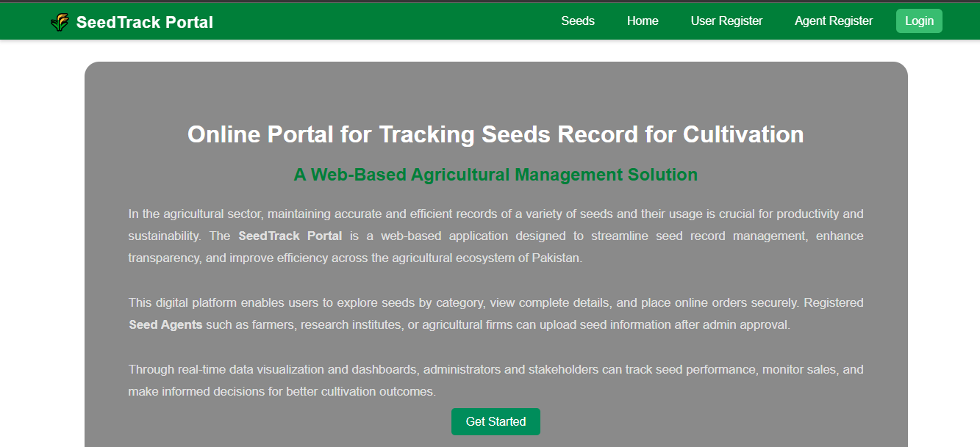
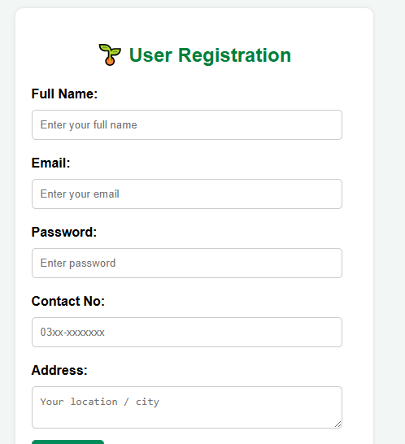

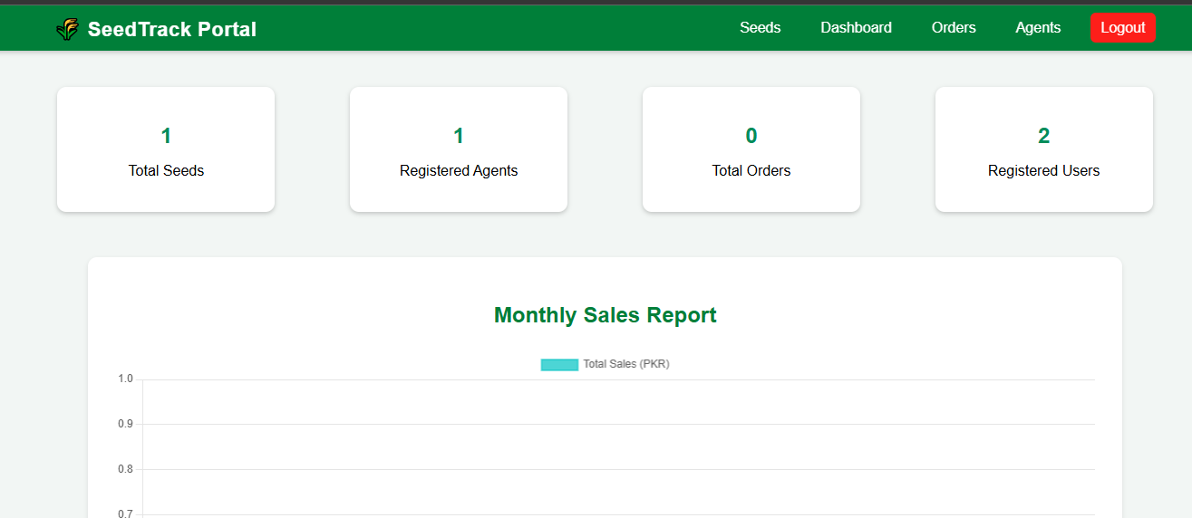

Chapter 3

Development

REFERENCES

Handouts CS504 – Software Engineering – I
Handouts CS5605 – Software Engineering – II
Handouts C403 – DMBS

APPENDIX

Section 1 | Gathering & Analyzing Info
Section 2 | Designing the Project
Section 3 | Development

